Accessing Nginx through EC2 instance.

Login into aws and create an ubuntu image

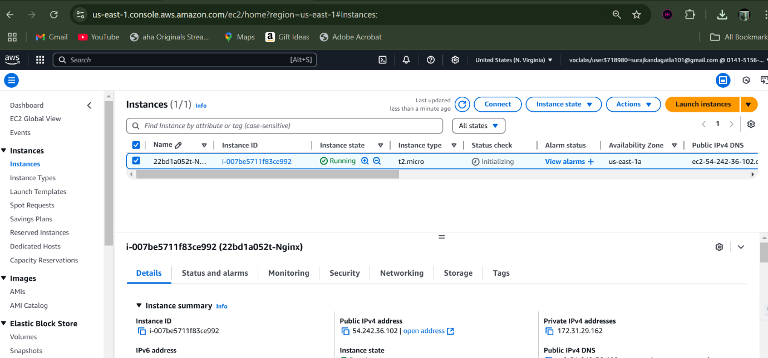

Then select the SSH client section to cop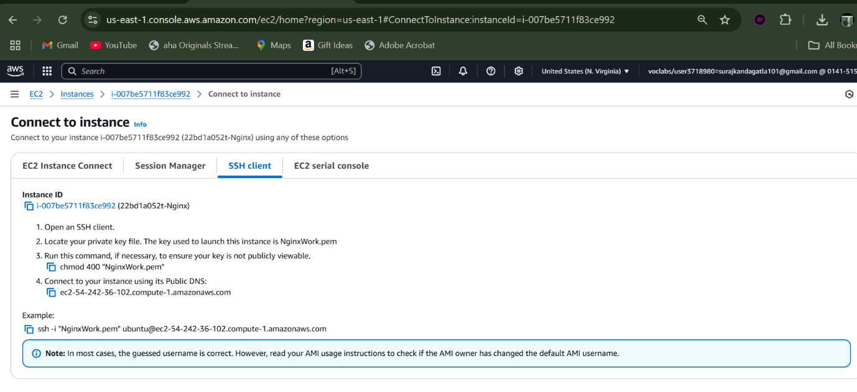

Create a folder and place your .pem file

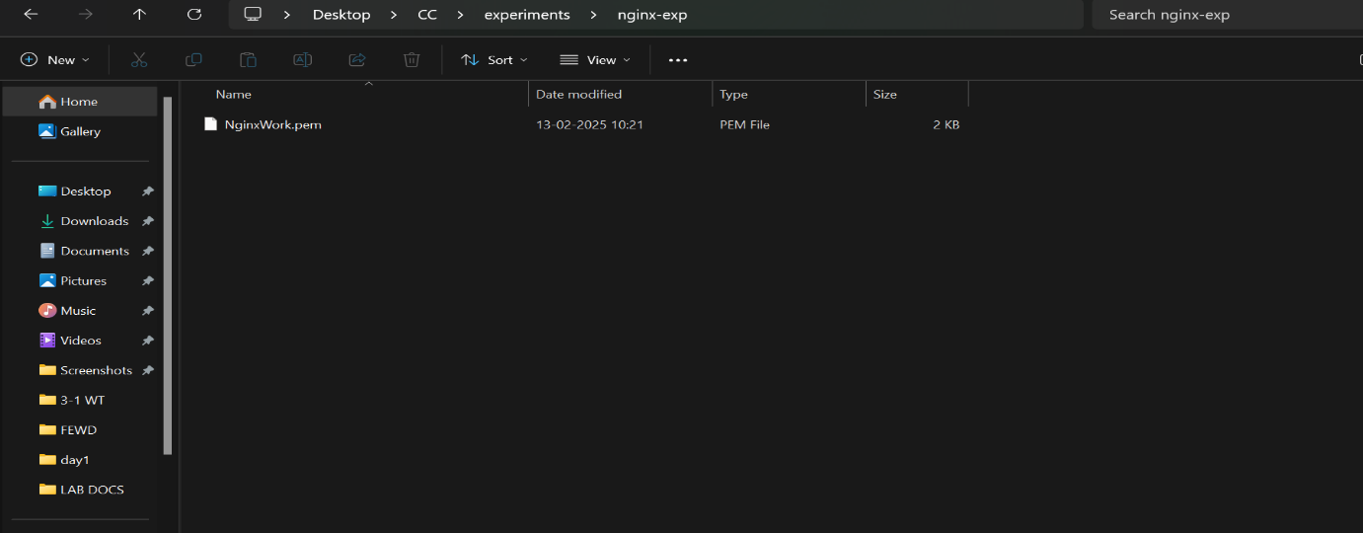

Now move to the current directory

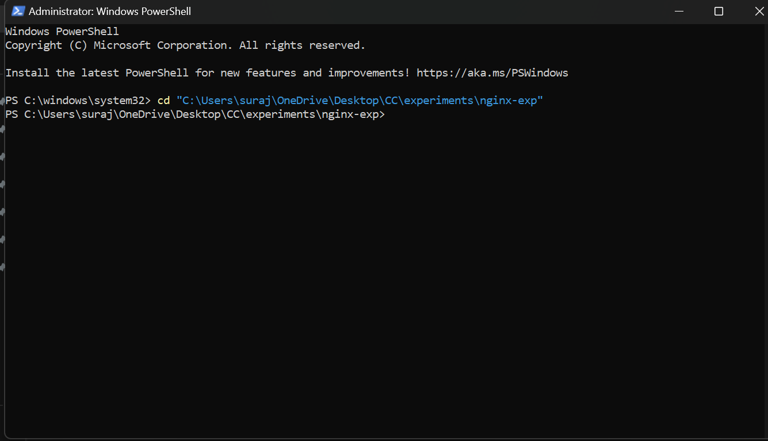

Connect to the instance using the command copied.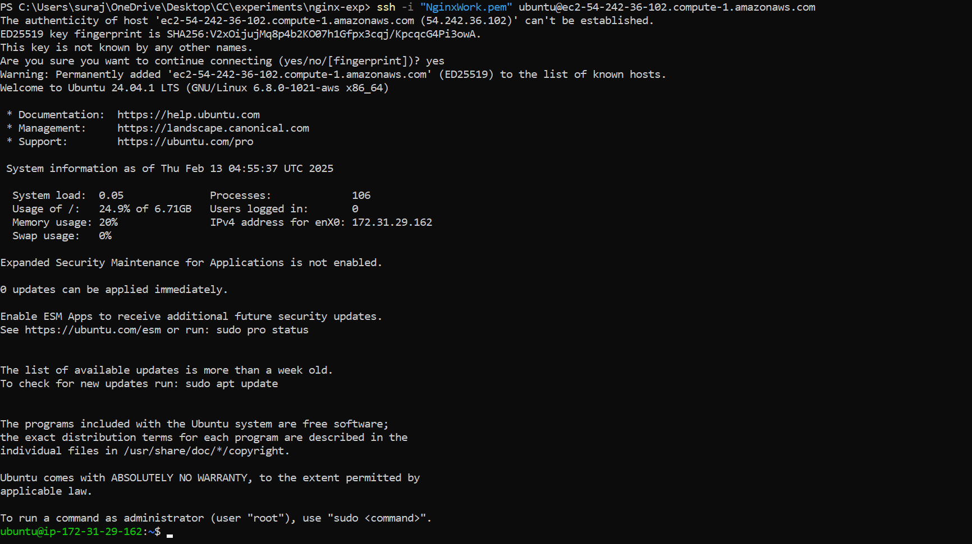

Update the instance.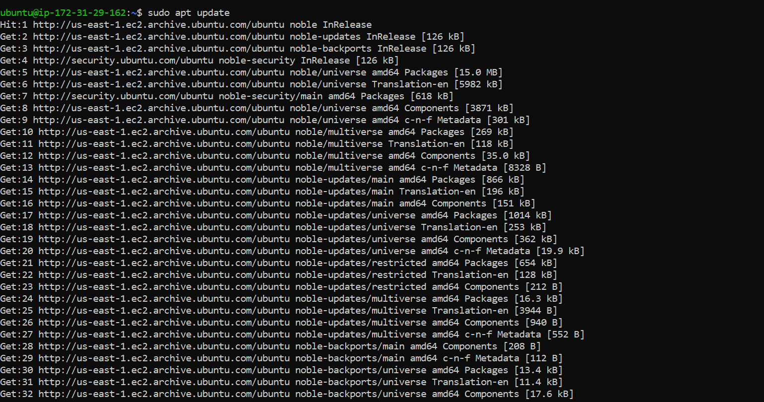

Now install docker 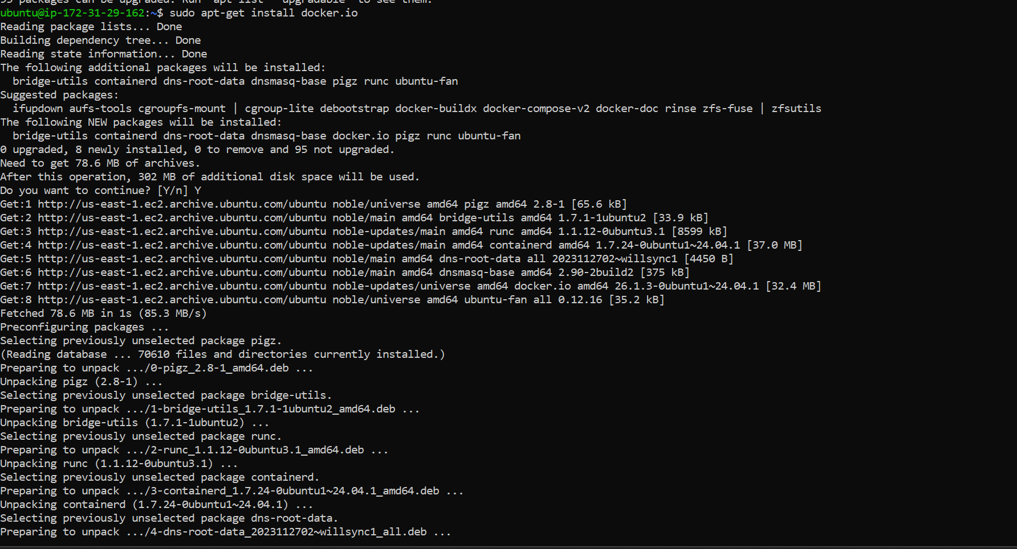

Pull the nginx image 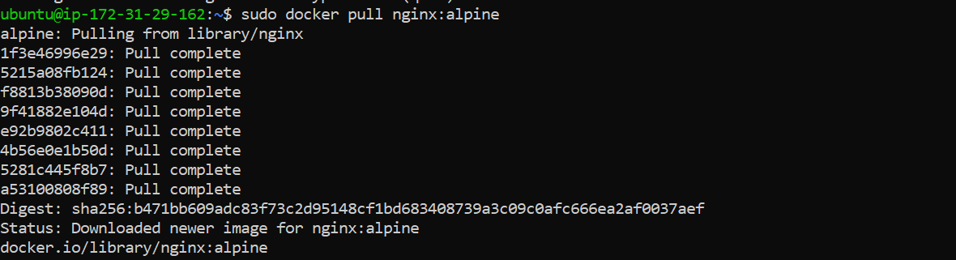

Now run the image and access it using public IPv4 of your instance

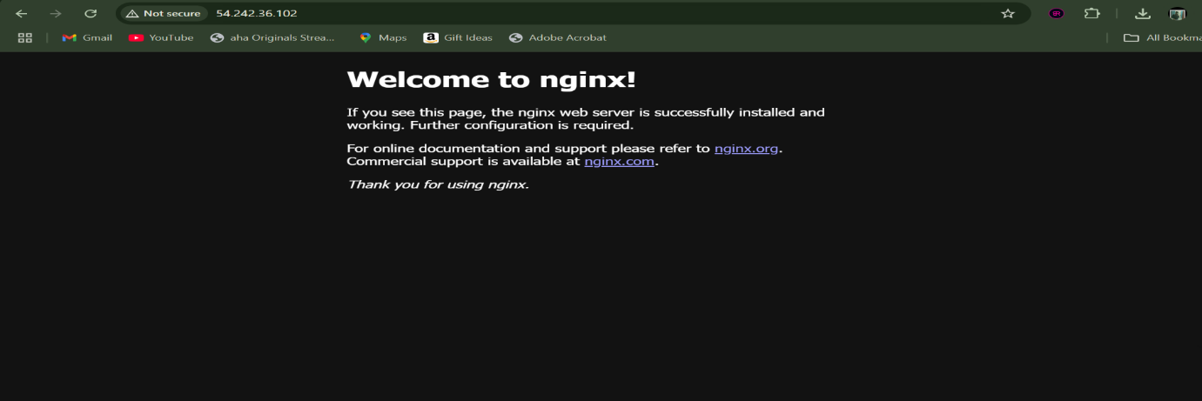

Now switch to interactive mode and navigate to html folder and create an index.html

Change the content of the html page according to use-case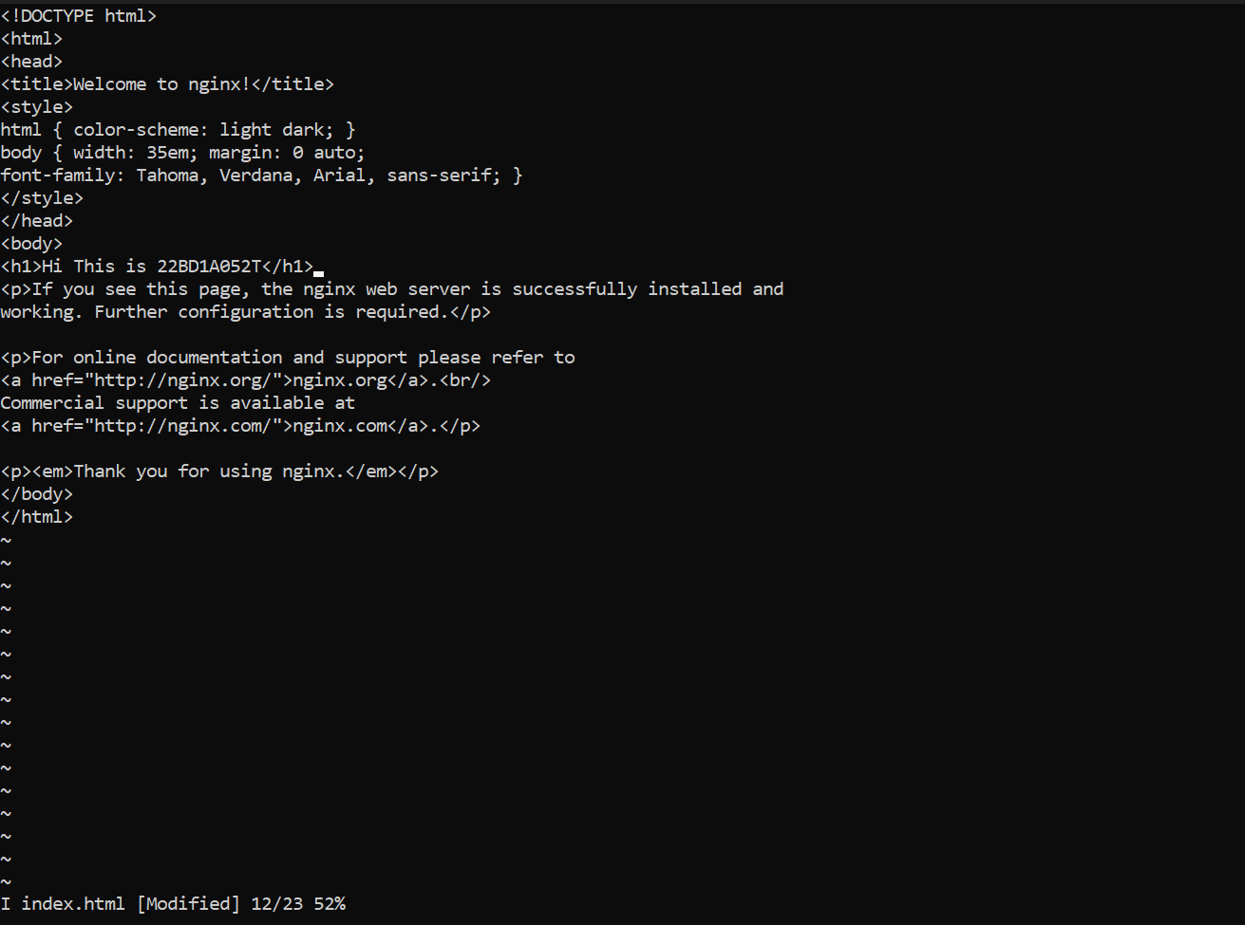

Exit from interactive mode.



Now this is our updated nginx application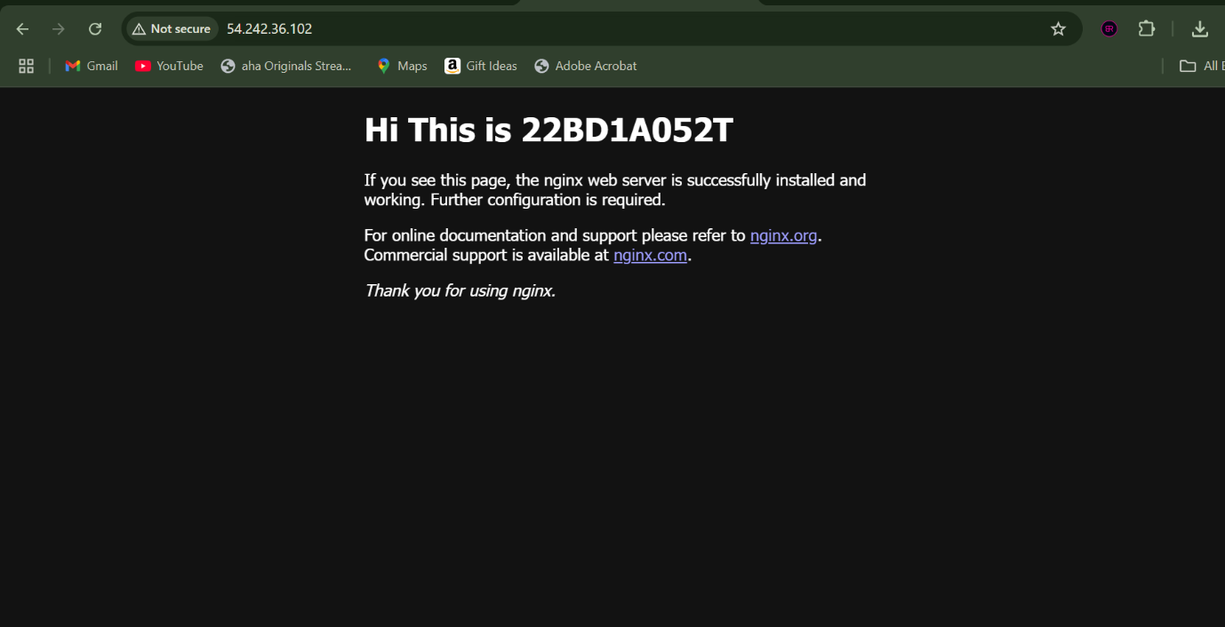

Stop and remove the container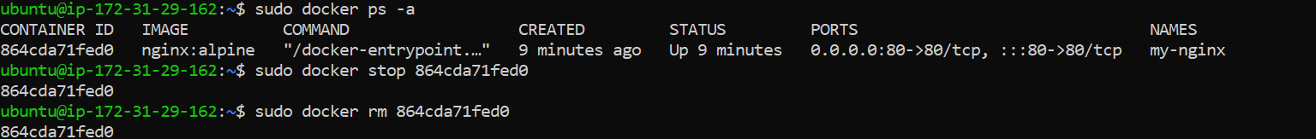

Remove the image which was pulled.  
